DBT ASSIGNMENT -5

1) Write a query that will give you all orders for more than Rs,1000.
Ans--
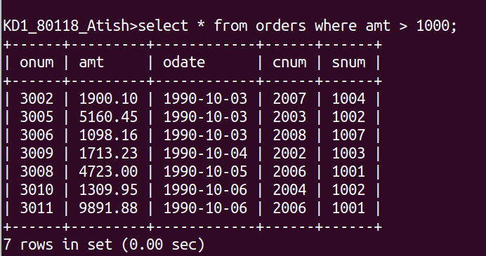

2) Write a query that will give you the names and city of all salespeople in London with a commisiion above .10
Ans--
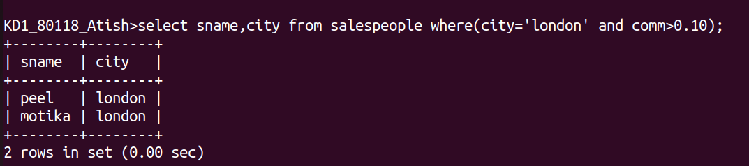

3) Write a query on the customers table whoose output will exclude all customers with a rating<=100, unless they are located in Rome.
Ans--
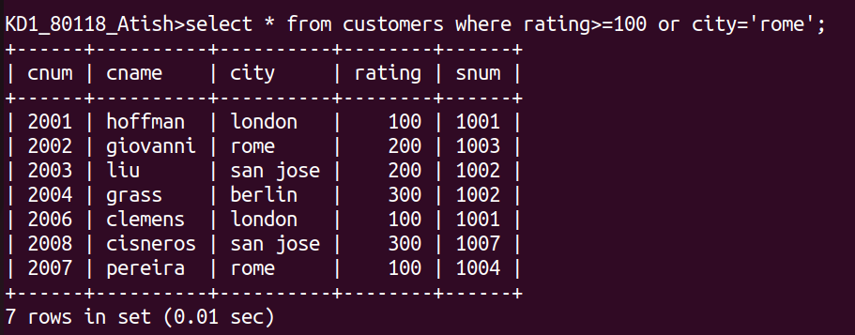

4) What will be the output of the following query;
select * from orders
where (amt<1000 OR
NOT (odate= ‘1990-10-03’ AND dnum >2003));
Ans--
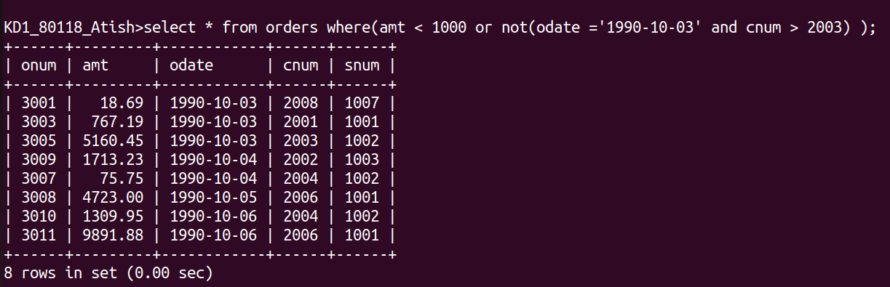

5)What will be the output of the following query.
Select * from orders
where NOT ((odate = ‘1990-10-03’ OR snum>1006 ) AND amt >= 1500);
Ans--
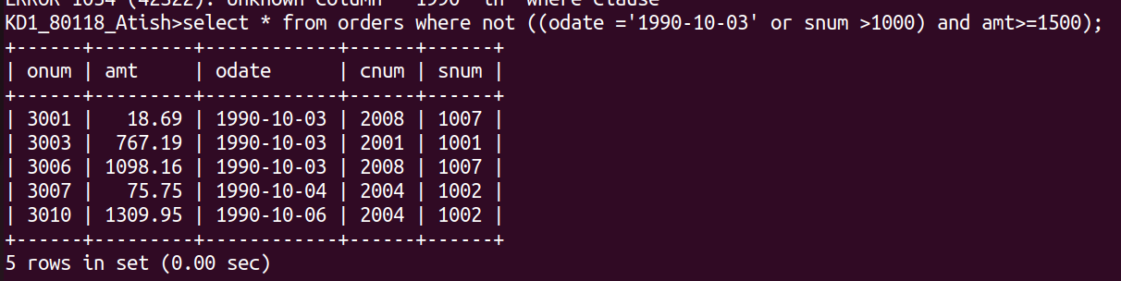

6) What is the simpler way to write this query.?
Select snum,sname, city, comm from salespeople where (comm > .12 OR comm < .14);
Ans--


